22th March 2016

**YOKOHAMA Test Drive Event in Sweden**

A group of YOKOHAMA dealers from several European countries, including Germany, UK, France, Italy, Norway, Sweden, Finland, Turkey, and Belgium recently attended a Winter Test Drive event at the YOKOHAMA Test Center of Sweden, which is the Japanese Tyre Manufacturer’s winter testing facility near the Arctic circle.

This year, over 170 dealers took part in the experience which helped to show the superior performance of YOKOHAMA winter tyres in both, the milder European winters and harsher winter conditions which include ice and snow particularly in the Nordic countries.

A number of tests of YOKOHAMA Winter tyres ranging from the excellence of the W*drive V905 to the iceGuard range - iG50 plus and iG55 which offer superb Nordic winter performance were extensively tested and included comparative tests with competitor brands, in different sections of the purposely designed Test Facility. Snow handling, Snow slalom, ice breaking, ice handling, and uphill traction, were among the practical experiences offered.

The delivery of product information seminars and presentations were also organised in conjunction with YOKOHAMA Europe staff and it’s Test Centre Team.

Throughout the experience YOKOHAMA dealers also had the opportunity to share information and discuss topics of interest with YOKOHAMA engineers, test drivers, instructors and country Distributors present.

As in other years, the event helped to explain and show YOKOHAMA’s high technology and superior product features to its dealers and to enable a thorough experience of driving under a variety of winter conditions.

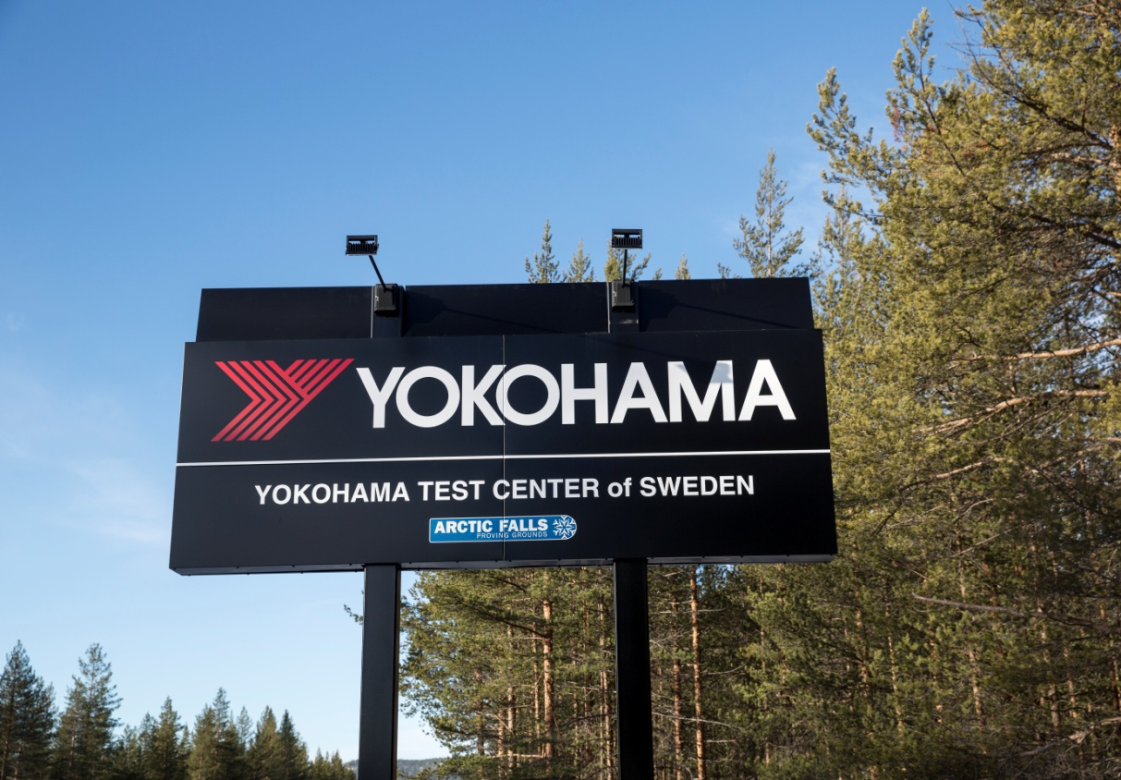

*YOKOHAMA Test Center of Sweden*